Database System Engineering and Distributed Backend Development
Course Code: 25CS13002E
ROLL NO:2520030527
NAME: K.Vansika Reddy
JOINS AND SET OPERATIONS
Query 1: Create the database:
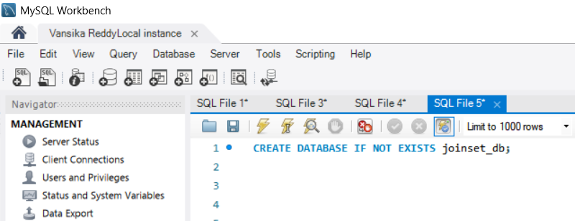
Output:

Query 2: Select the database:
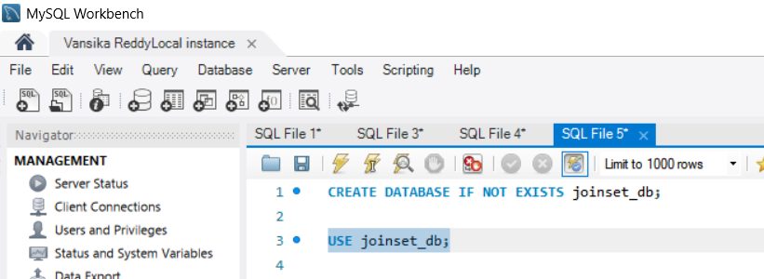Output:

Query 3: CREATE TABLES:
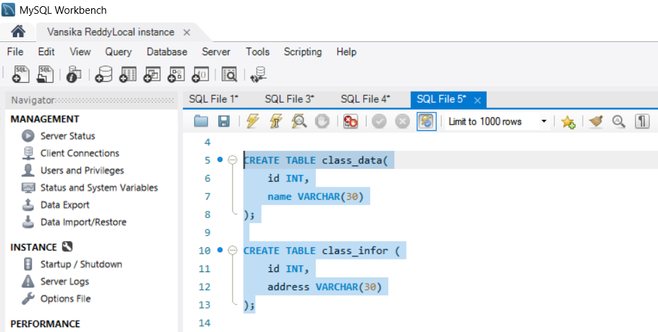
Output:

Query 4: INSERT DATA
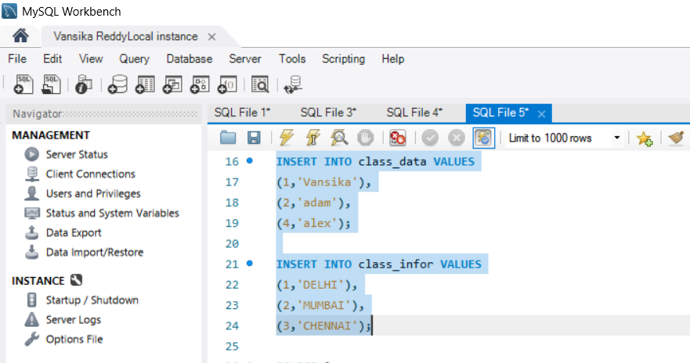

Output;

Query 5: CROSS JOIN:
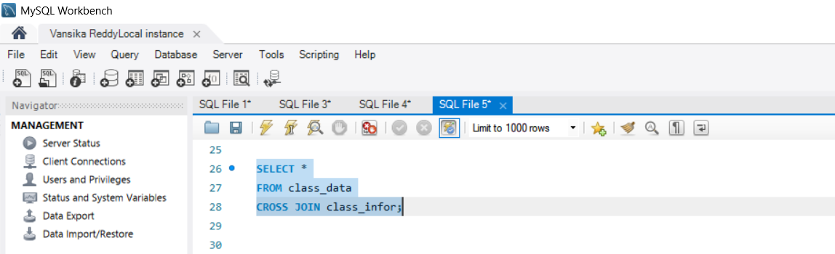

Output:
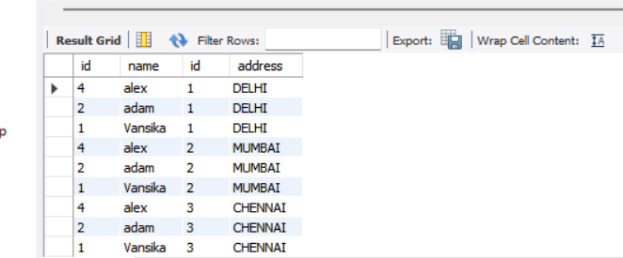

Query 6:
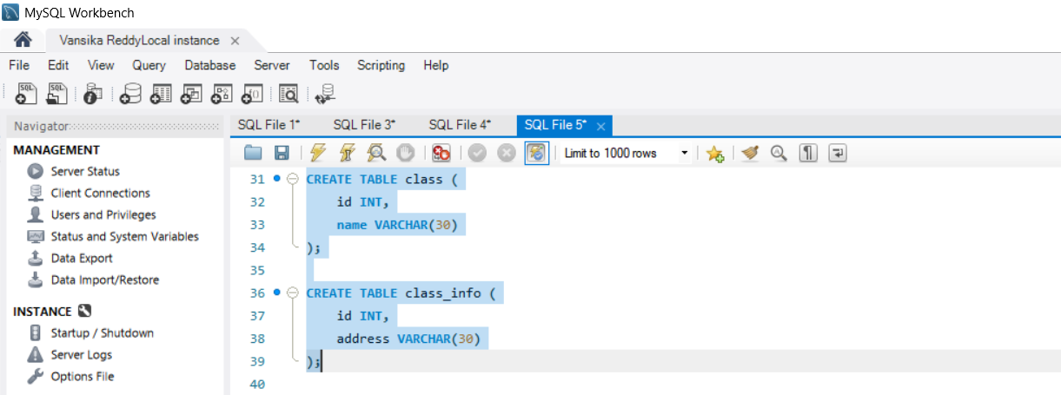

Output:

Query 7:
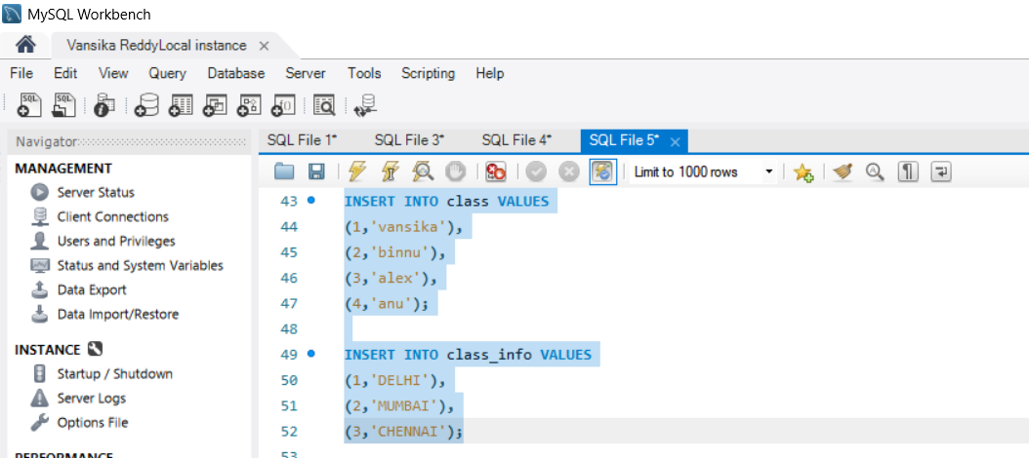

Output:

Query 8: INNER JOIN
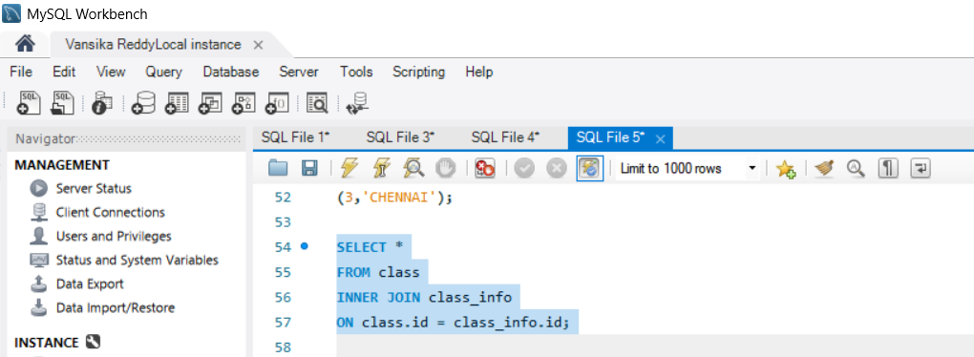

Output:
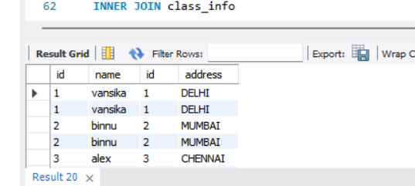

Query 9: INNER JOIN
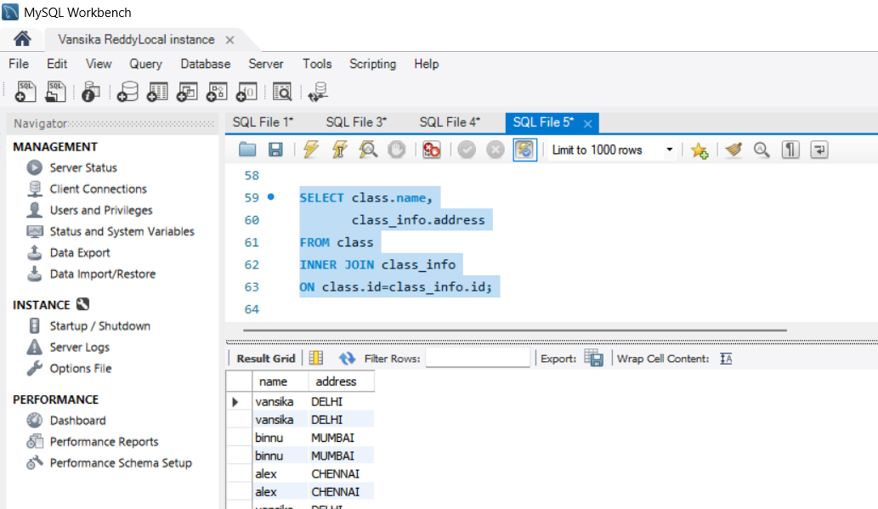
Output:

Query 10: NATURAL JOIN
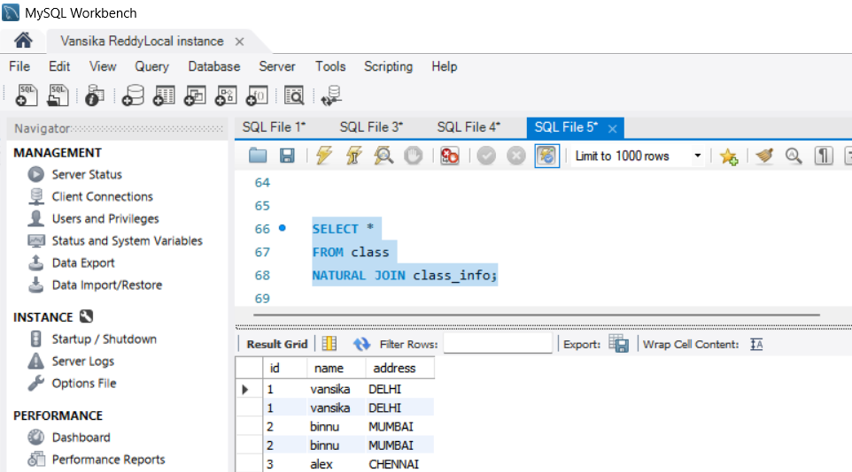
Output:

Query 11:
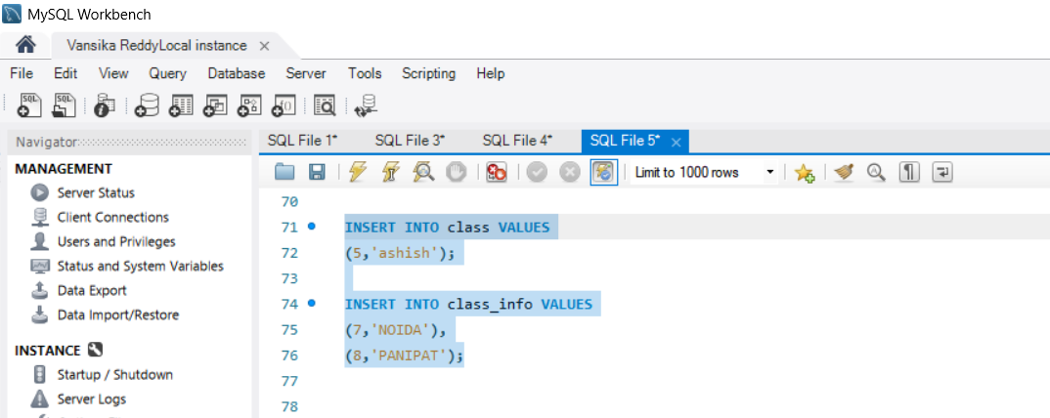

Output:

Query 12: LEFT OUTER JOIN
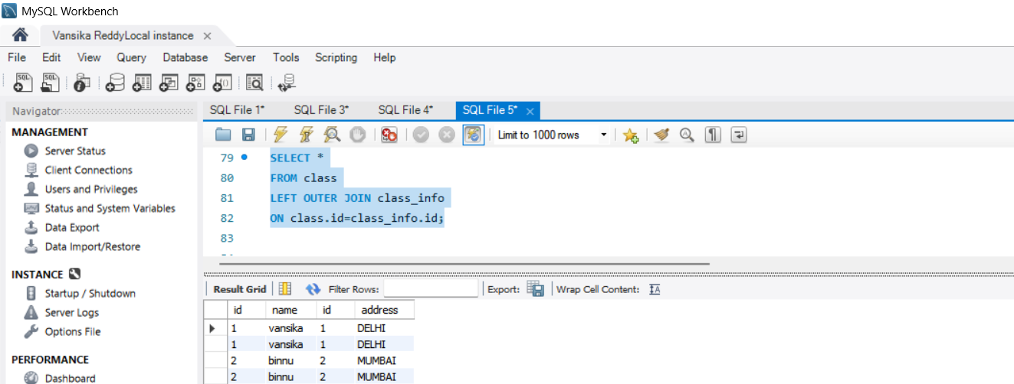

Output:

Query 13: LEFT JOIN
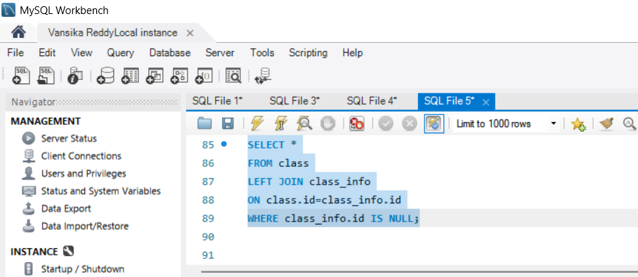

Output:

Query 14: RIGHT JOIN
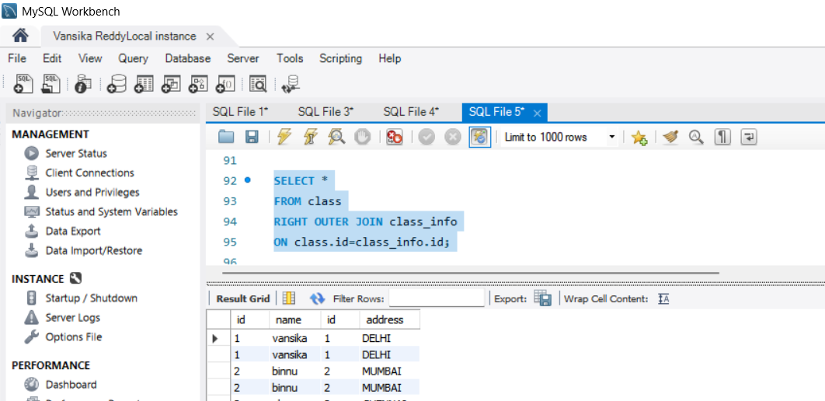

Output:

Query 15:RIGHT JOIN
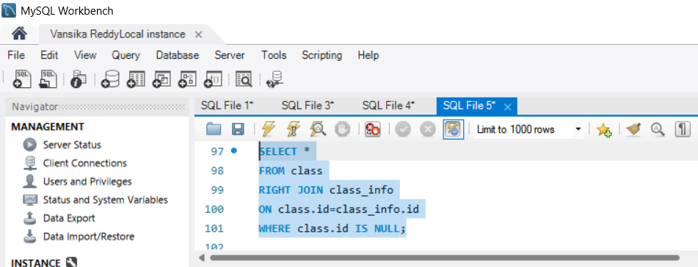

Output:
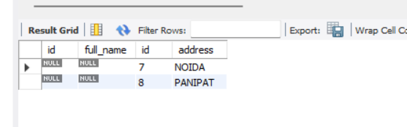

Query 16: FULL OUTER JOIN
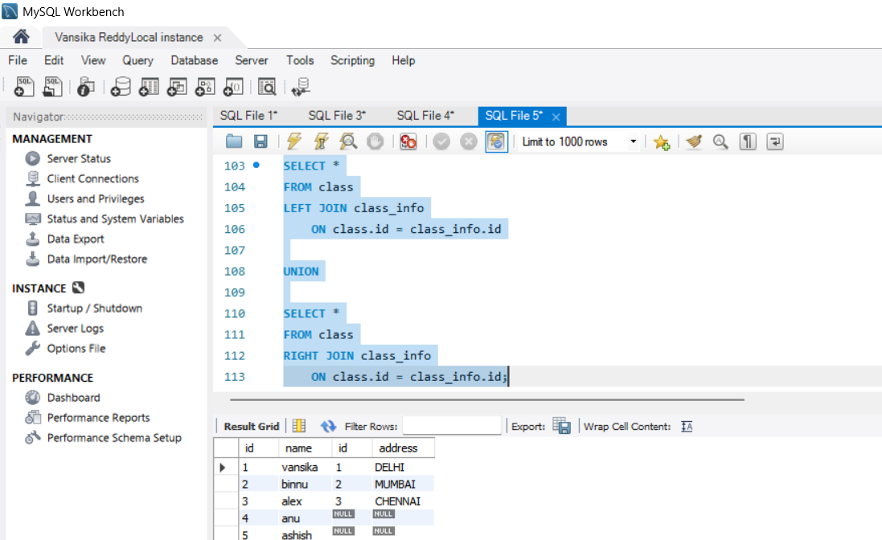

Output:

Query 17: FULL OUTER JOIN
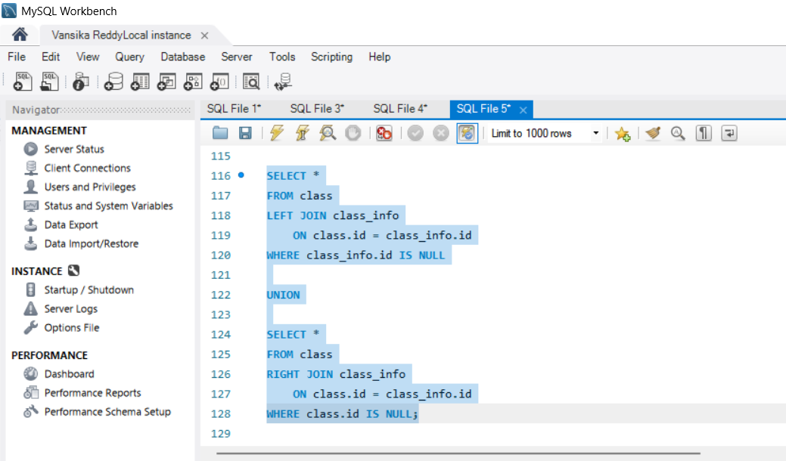

Output:
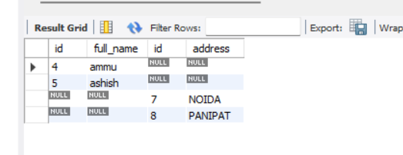

Query 18: UNION
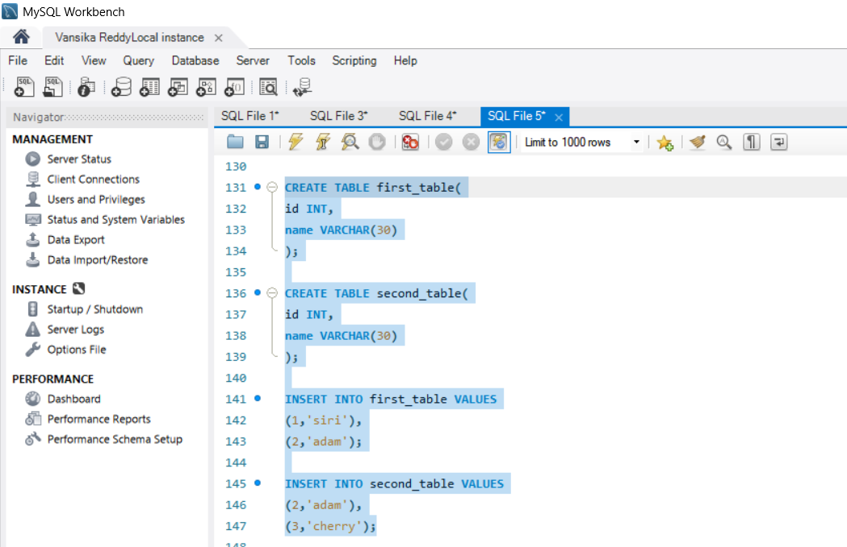
Output:
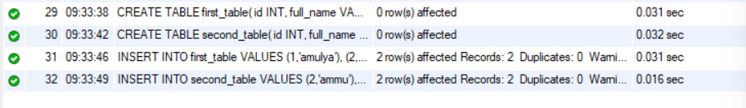

Query 19: UNION
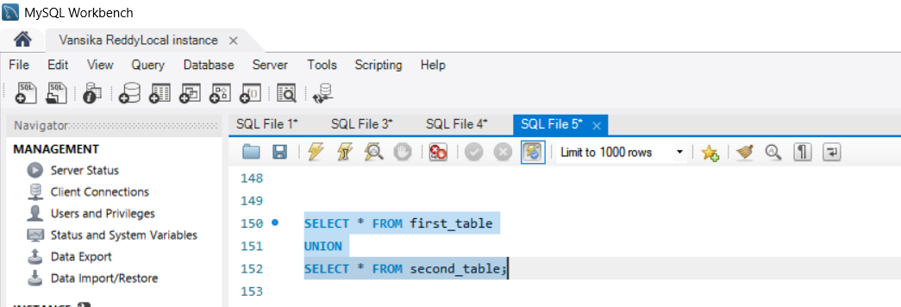

Output:
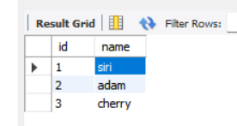

Query 20: UNION
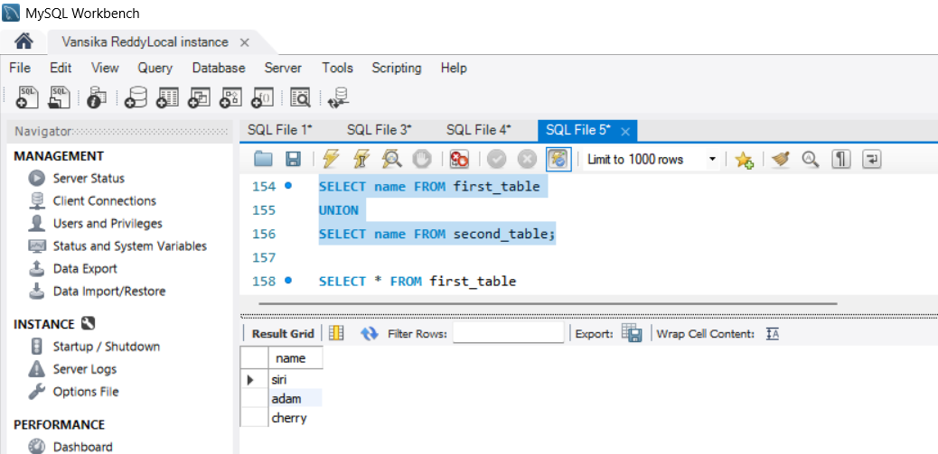

Output:

Query 21: UNION ALL
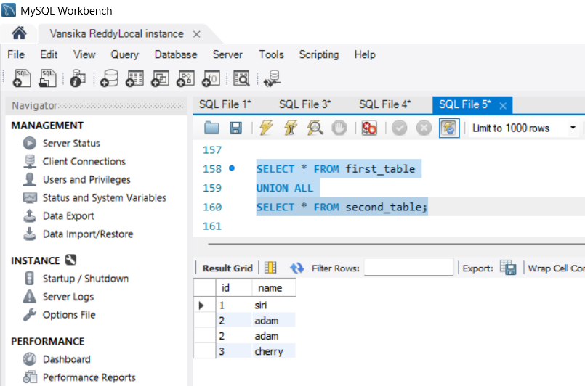
Output:

Query 22: UNION ALL
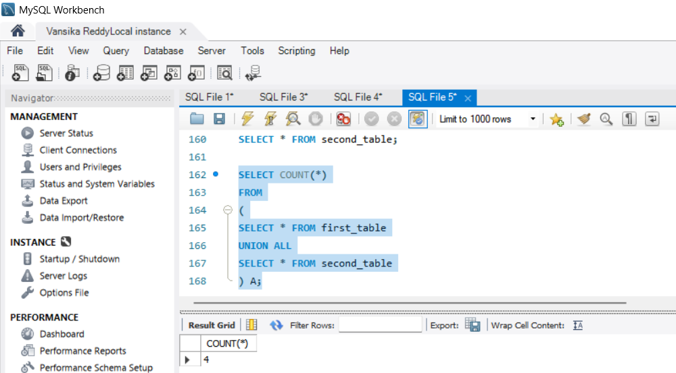

Output:

Query 23: INTERSECT
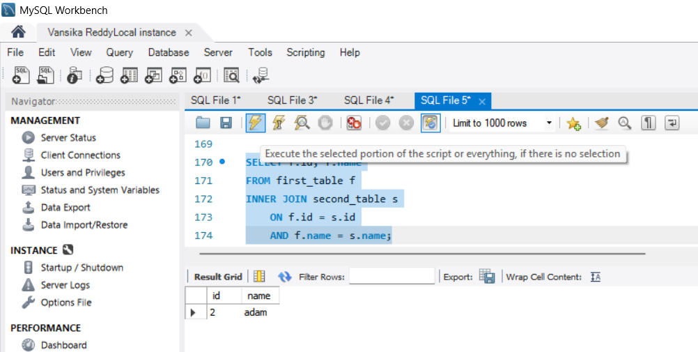

Output:

Query 24: INTERSECT
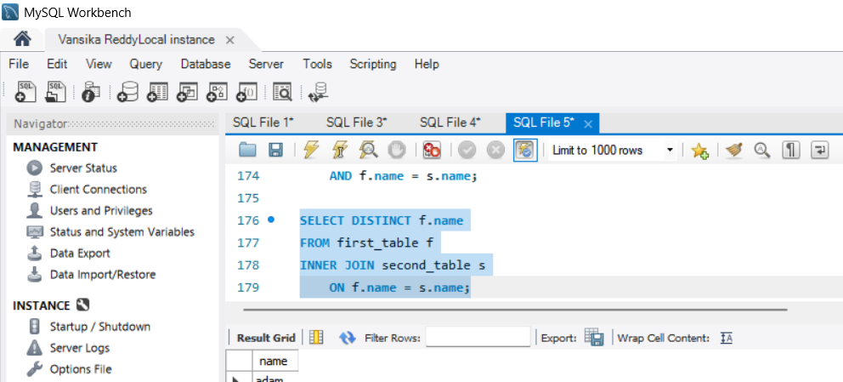

Output:

Query 25: MINUS
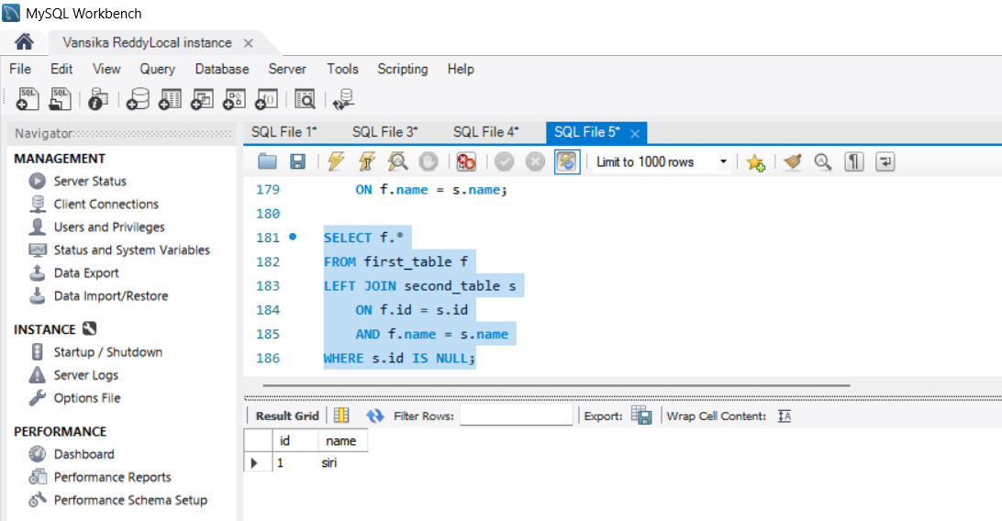

Output:

Query 26: MINUS
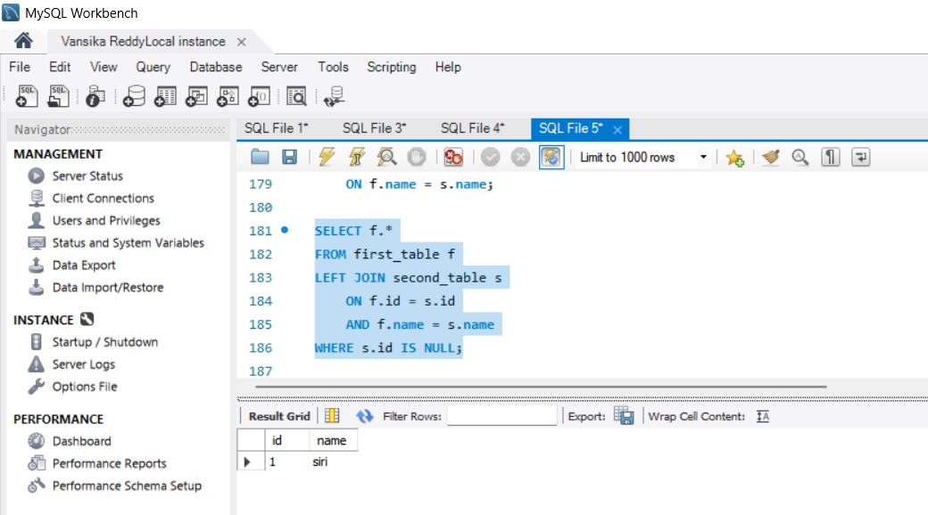

Output:

